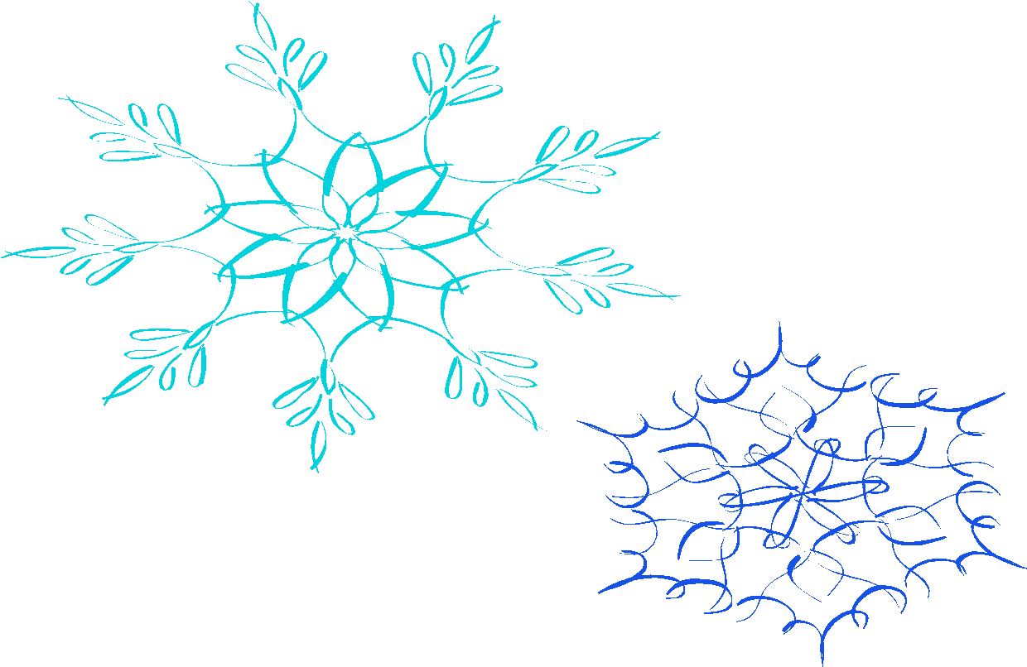
Dear Parents and Students,
I hope everyone enjoyed their winter break. I missed my students and can’t wait to get back to our routine again! Outlined below are a couple of reminders.
Indoor shoes
As the snow and cold flies, please make sure your child has an extra pair of shoes for inside the classroom. Because students work on the floor with material, I ask students to leave their boots or other wet shoes out of the classroom. Also, students have PE on Tuesday, please make sure they have gym shoes in order to participate.
MAP Testing/Delta Math
Students will begin winter MAP testing in January. They will be tested in math and reading. A little extra sleep this month can go a long way for students. Delta Math is a quick check on basic computation you need to already be able to do in order to do the current grade’s curriculum.
Important Dates to Remember
Monday, January 8th: Camp meeting at 6:00pm in the gym.
Thursday, January 11th: 4th Graders to Frederick Meijer Gardens: Researching different Biomes. We leave at 9:30am and return around lunch time.
Monday, January 15th: No School
Wednesday, Thursday and Friday January 24th-26th Early Dismissal at 12:35 (hot lunch will be served on these days).
Snack
Wow! Thank-you so much for your snack donations. We love the extra snacks. Some healthy options are cheese sticks, fruits, vegetables, pretzels, beef sticks, cheese, crackers, cereal bars, or dried fruit.

Math IXL
How is math IXL coming at home? My goal is for students to get into a routine of practing math at home a couple times a week. I also have a new webite that might interest your child its called Prodigy math and it’s free. The website is www.prodigygame.com.

Community Service
In December students were able to practice some community service at school. Our class helped out Mrs. Keiler’s class make gingerbread houses. Students will receive a lesson this week on January’s community service. I will send home the note this week.

PBIS/Grace and Courtesy
The students and I will be reviewing the class and school expectations this week.
Teaching organization is a large part of an upper elementary Montessori classroom. The students and I will be reviewing organization. Students already help each other out with organization. I’m guessing that this will be mostly student lead.

Thank-you for your support. If you have any questions or concerns, please don’t hesitate to reach me at skippt@grps.org or 616-299-6272.

Sincerely,

Theresa Skipp

